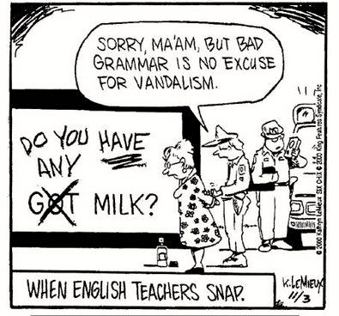
English 12 Course Outline

“It is in fact a part of the function of education to help us escape, not from our own time -- for we are bound by that -- but from the intellectual and emotional limitations of our time.” T.S. Elliot

“What is important is to keep learning, to enjoy challenge, and to tolerate ambiguity. In the end there are no certain answers.” Martina Horner

“Intelligence plus character--that is the goal of true education.” Martin Luther King, Jr.

COURSE OBJECTIVES

By the end of English 12, you will have read a wide range of literary genres and will be able to recognize and analyze literary terms and elements associated with each genre. You will be able to read at a literal, interpretive, and critical level, and you will be able to respond to literature personally and analytically. You will improve on essay writing skills introduced in English 11, and you will be able to use rhetorical techniques to write literary, persuasive, narrative, and comparative essays.

English 12 is a challenging course, so be prepared to work hard. In addition, I hope that you gain confidence and enjoyment in all areas of English!

COURSE CONTENT

You will develop your reading skills through the formal study of literature, including short stories (which will come from Imprints 12 and other sources), novels (such as Of Mice and Men and other self-selected novels), Shakespeare (such as Taming of the Shrew), and poetry.

You will develop a variety of writing skills including the following:
- Narrative and descriptive writing – by writing poetry, original fiction, and memoirs.
- Reader response – by analytical and personal responses to literature.
- Persuasive and comparative essays – by refinement of pre-writing, organization, topic/thesis, cohesion, and persuasion.
- Writing Process – by focusing on freewriting, revision and editing.
- Vocabulary expansion – by learning words in context (usually within literature).
- Conventions – by learning about and correcting sentence faults, usage, punctuation, etc.
Finally, you will develop your oral language skills, through both informal discussions and formal oral presentations.

As English 12 is a government examinable course, you will be given some time to prepare for it in class through taking sections of previous exams for practice. Class work accounts for 60% of the final grade. Students will write a government exam at the end of the semester comprising 40% of your total grade.

MATERIALS REQUIRED

For each class you will need to bring the following:
- a three-ring binder with an ample supply of lined paper and writing utensils
- a blue or black pen, a red (or different-coloured pen) and pencil.
- the text we are studying. You will not be permitted to return to your locker to retrieve forgotten items.
- Drinks and food are permitted, as long as the classroom is kept clean. This is a privilege that will be taken away if not respected.

ASSESSMENT AND EVALUATION

Process – 60% Practice in class, drafts, questions, discussions, journals, reflections etc.
Product – 40% Essays, research projects, presentations, quizzes, tests.

STUDENT EXPECTATIONS
Behavior – Classmates and the teacher are to be treated with respect and courtesy at all times.

Attendance. Check the class website for any missed work or missed assignments. It is your responsibility to ensure that all work missed is completed. Be prepared to take any missed tests/quizzes the day of your return.

Punctuality – Obviously students are expected to arrive on time. Those who arrive late must sign in quietly and take their seat. (Please do not disrupt the class.)

Assignments – All work must be handed in on a specified due date. Be sure to contact another student or myself BEFORE 8 P.M. at tferris@sd73.bc.ca. Be aware that I may ask you to re-do an assignment if I feel it is insufficient (e.g. if it is illegible or careless.)

Plagiarism – Plagiarism is passing off another’s ideas as your own; it is a serious offense. It will result in the failure of the assignment and a referral to administration.

